Scottish Directors of Public Health

Public Health Priority 2: A Scotland where we flourish in our early years

Wellbeing in our early years can determine health and social outcomes throughout the lifecourse, and children’s wellbeing is particularly susceptible to the impact of their life circumstances. Getting It Right for Every Child (GIRFEC) is the bedrock of Scottish policy for children and young people and is based on a model designed to meet the terms of the UNCRC and the Human Rights Act. The ‘My World’ Triangle was developed in Scotland to summarise the model as a whole system approach to understanding the factors children need to flourish under the domain headings of ‘how I grow and develop’; ‘what I need from people who look after me’; and ‘my wider world’. The triangle can be used as the starting point for a driver diagram to identify actions required at individual, family and society level to improve wellbeing and to reduce inequalities in outcomes for the early years.

Actions to ensure flourishing in the early years and reduction in inequalities in opportunities and outcomes are needed throughout the lifecourse, including during pregnancy, childhood years and from adolescence through to parenthood. This means that families, children’s services, adult services with impact on children (eg housing, mental health, substance use and many others), community services and facilities, employers of parents and young people, and structures for community culture, safety and fiscal policy are all implicated in enabling a good and fair start in life. Responsibility for actions therefore lies across all political portfolios in Scotland creating complexity at government level in planning and accountability for children’s wellbeing outcomes.

Public Health Priority 2 offers an opportunity for the DsPH to articulate a clear preventative strategy for the whole system to improve health and reduce inequalities in the population, with its roots in flourishing in the early years. DsPH can establish leadership action on prevention in all three domains of the ‘My World’ model at local and national levels and additionally strengthen whole system action on the ‘wider world’ determinants of health and health inequalities that are particularly important in the early years. The DsPH Children and Young People Public Health Group (CYPPHG) offers a body of work and established local and national relationships to build on. The group are in the early stages of developing its work programme in collaboration with the Scottish Government Directorate for Children and Families, the Child Health Commissioners (CHCs) and with COSLA.

The CYPPHG was established to strengthen collaborative action across the Scottish public health system with a focus on the determinants of child health. The Group comprises public health specialists from Health Boards with a leadership role for child health in local and national public health teams, networks, programmes and services within the NHS and multi-agency partnerships. Through the group there are active local/national collaborations for influencing practice and strategy on child poverty, childhood adversity, children and young people’s mental health, preconception health and relevant consultation responses as required; and local collaborations working to influence Scottish Government strategies for the national review system for child deaths, and data and governance for child health surveillance. The group also provides information exchange on individual work programmes. There is an opportunity through PHP2 to bring together the work programmes of the DsPH group, the Child Health Commissioners and COSLA’s Children and Young People Board in order to strengthen leverage on prevention actions across the system.

Summary of current CYPPHG work programme priorities and gaps, and potential areas for collaboration across the My World triangle

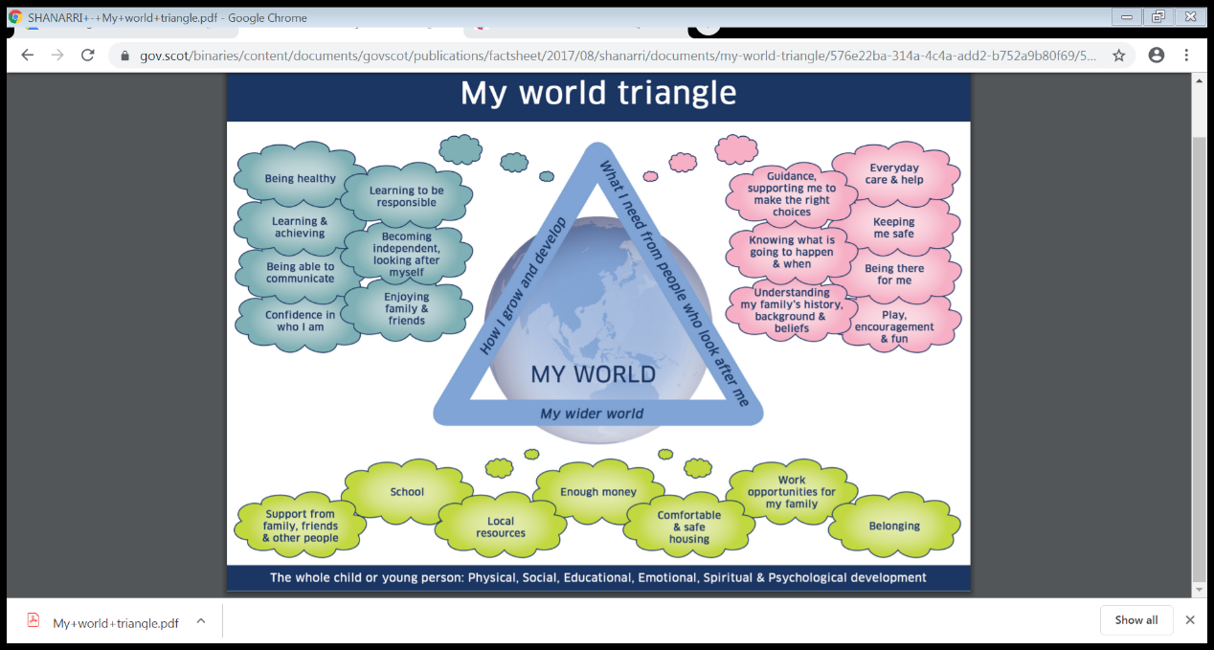

How I grow and develop:
- Data systems; consistency, cross organisational, new datasets, analyses and application, governance eg CHI, new maternal and neonatal health database (DsPH/CHCs)
- Preconception health (DsPH/COSLA)

What I need from people who look after me:
- Focus on groups with additional needs eg care review, equitable access to resource eg PEF (DsPH/COSLA/CHSs)
- New services based on known need, eg child death reviews, children and young people’s mental health (DsPH/CHCs/COSLA)

Wider World:
- Whole system approaches to child poverty and adversity in childhood
- Full implementation of wider world domain of GIRFEC (DsPH/COSLA)

Gaps:
- Policy focus on inequality in early years and population groups with highest levels of need for preventative action (DsPH/COSLA/CHCs)
- Governance for preventative action (DsPH/COSLA/CHCs?)
- Joint prioritisation and planning (DsPH/COSLA/CHCs)

Draft 1.2 for further discussion

