Public Health Priority 5 - sustainable and inclusive economy: towards a DsPH Action plan
Debs Shipton, Gerry McCartney, Shifa Sarica, Rebecca Campbell
February 2020

A draft theory of change for PHP5 was developed by NHS Health Scotland and refined based on feedback from stakeholders. It identifies the long- and medium-term outcomes required to deliver an inclusive and sustainable economy in Scotland (Figure 1). This is particularly important for population health given the role of economic factors in causing the stalling of life expectancy trends since around 2012.
This document begins to identify actions that the Directors of Public Health and their teams can take to maximise their contribution in this area.

Leadership
This is a new area for public health. Leadership will be required in order to provide a vision, set the direction, prioritising resource and to achieve influence and change. This includes facilitating effective communication of public health evidence on the impact of economic and social security policy on population health and inequalities to all relevant policymakers at all levels. We also have the opportunity to help in the reframing of the objective of the design of the economic system towards a wellbeing economy.

NHS as an anchor institute
The NHS is a substantial economic actor in its own right. There is a growing evidence base showing how the NHS can support health and wellbeing in the geographical areas and economic systems in which they are located. We have already undertaken work in this area in Scotland and there are opportunities to learn and do more in the future. The ways in which we can act include through the NHS procurement chains, land use, employment practices (e.g. by paying the Real Living Wage), through our partnership arrangements, and by reducing environmental impact.
There is much more than can be done by the NHS boards in Scotland in this area and there is a vital role for public health staff to move this agenda forward. A Health Scotland report provides a practical guide for how the NHS can reduce inequalities, use their procurement and employment practices to support a more inclusive economy, and use its advocacy voice.

Also read
- Building healthier communities: the role of the NHS as an anchor institution. Health Foundation.
- Economic Influence of the NHS at a local Level. Kings Fund.

Income
Income maximisation interventions have been effective in increasing the income of those that need it most. There is a central role for public health to ensure current practice to support income maximisation and welfare rights services is working well. In addition, we should support innovation and evaluation of new models of delivering effective income maximisation interventions.
There is a role for public health teams to disseminate evidence to relevant decision-makers on the policies and practices that reduces inequalities (avoiding those that are likely to increase them). The NHS Health Scotland Triple I tool identifies how a number of different interventions impact on inequalities.
Also read
- Impact of income policies on health. NHS Health Scotland

Economic strategies
Regional and local economic and industrial strategies now largely focus on delivering an inclusive economy. There is an ongoing need for public health perspectives and evidence to be used in the development and delivery of these strategies in order to maximise the positive impacts on population health and inequalities and to minimise the negative consequences. Examples of work in this area might be to contribute to the planning and implementation of the regional and city deal capital investments; to undertake health impact assessments; and to influence public policy on tax, social security, planning, housing and regeneration.

Environmentally sustainable practices

How we design the economy has a profound influence on the environmental impact we have. It is therefore important to ensure that policy and practice achieves population health outcomes, equity and environmental sustainability. This can be achieved by routinely undertaking comprehensive impact assessments and finding win-win policies and practices.

Monitoring and evaluation
The impact of PH action towards delivering PHP5 should be monitored and reported on. Discussions are soon to get underway with the Scottish Government about developing a monitoring and impact framework. Ensuring that high quality evaluation is built into relevant interventions will greatly assist in this endeavour.

Ways of working

In the initial discussions around PHP5 some implications for our ways of working have been identified:
- We need to provide a means of networking and co-ordination between those working in the area of PHP5 at national and local level so that we can support and learn from one another. We are therefore asking DsPH to identify people working in their teams in this area and link them to the PHP5 group chaired by Emilia.
- We need to make links to existing national groups working in this area e.g. on Welfare Reform (the Health Impact Delivery Group), Health and Employability Group, etc.
- We need to identify skill gaps across public health teams to allow us to operate successfully in this area.
- We need to build upon and operationalise the theory of change (Figure 1) into practical actions that can be taken forward within the public health workforce.
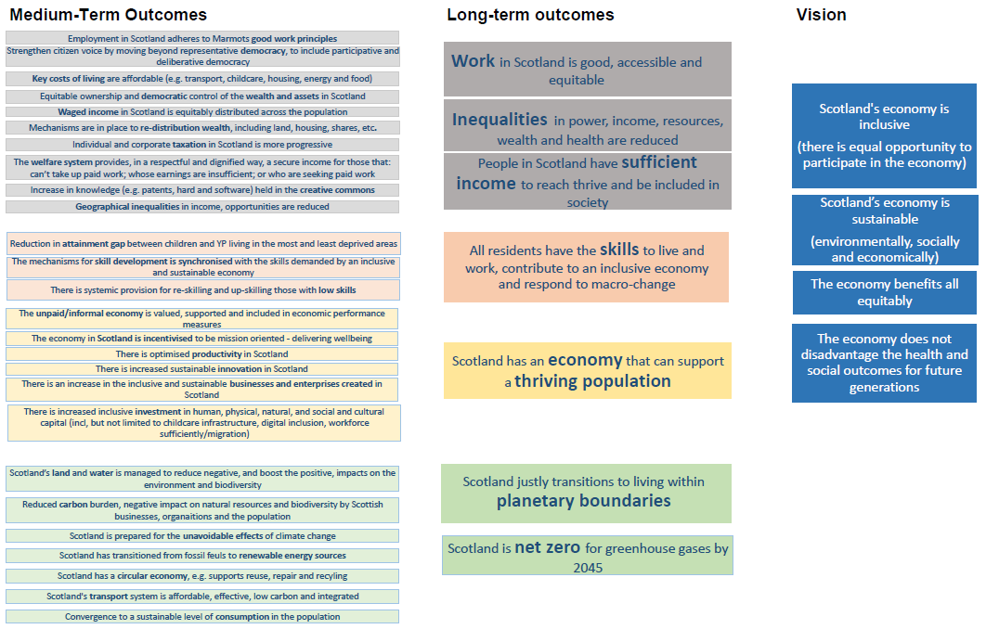
Figure 1: Draft theory of change to deliver an inclusive and sustainable economy

McCartney G, Fenton L, Morris G, Mackie P. ‘Superpolicies’ and ‘policy-omnishambles. Public Health in Practice 2020; 1: 100003, https://www.sciencedirect.com/science/article/pii/S2666535220300021.

