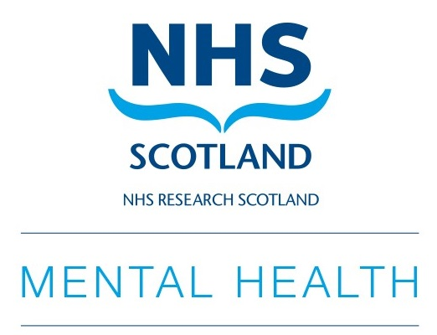

Annual Scientific Meeting of the NRS Mental Health Network

‘Lost in Translation?
Bringing research evidence to practice and policy’

Date: 29th October 2019
Time: 9am – 5pm
Venue: University of Strathclyde
Technology & Innovation Centre
99 George Street, Glasgow, G1 1RD

REGISTRATION DETAILS

Title (please circle/delete) Mr. Mrs. Ms. Dr. Prof. Other____________
First Name ________________________________________________________
Last Name ________________________________________________________
Job Title ________________________________________________________
Organisation _______________________________________________________
Department ________________________________________________________
Email address _______________________________________________________
Phone ______________________________________________________________
Address ________________________________________________________
Dietary Requirements: _________________________________________________
Wheelchair Access: Y / N
Any other requirements: ________________________________________________

Please return this form to:

Email: info@smhrn.org.uk
Post: NRSMHN Administrator, 2nd Floor, Kennedy Tower,
Royal Edinburgh Hospital, Edinburgh EH10 5HF

If you have any queries please contact: lisa.y.martin@ed.ac.uk
or phone 0131 537 6542.

Please tick here if you do not want to be added to the NRSMHN mailing list:

